**Step 1 – Rough Research**

Research information about the software for your assigned operating system (OS) environment.

· Guide your research according to the suggested topic list below

· Feel free to copy-and-paste as long as you keep track of your bibliographic references.

· Do not be too picky or concerned about formatting as you will organize this information later in step 2

· Select things that look interesting and don’t forget to include graphics images as well

· Upload your rough research notes to your repository when you are done.

Topic A – Productivity & Application Software

### **[Toggl](https://toggl.com/?utm_source=zapier.com&utm_medium=referral&utm_campaign=zapier&utm_source=zapier.com&utm_medium=referral&utm_campaign=zapier)**

*Best for tracking time while remote*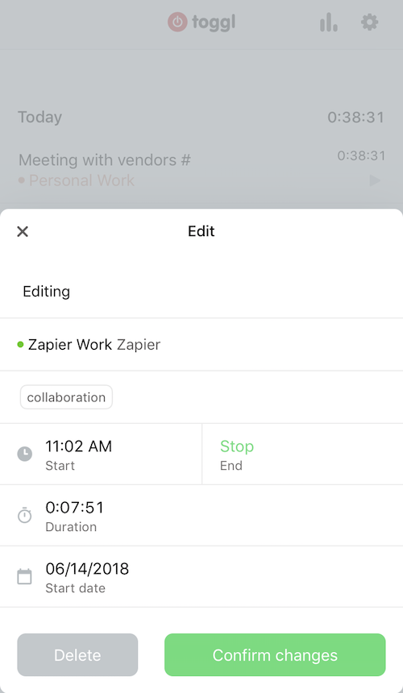

Toggl is among the [best time-tracking apps](https://zapier.com/blog/best-time-tracking-apps/), and it stands out on the iPhone for its ease of use. If you need to track time spent in meetings, at a client visit, or while doing anything when you're away from your desk, Toggl is the best app for the job on iPhone. Whether you need to keep tabs on billable hours or simply want to record time on task for your own productivity purposes, it's the app to download. Toggl also wins hearts for having a free tier of service that's actually quite useful, though you may need to pony up to a paid plan for additional reporting tools and project management features. Toggl works across a number of platforms (Android, Chrome, Linux, macOS, web, Windows), and time you record via the iPhone app will sync to your other devices.

Price: free; paid plans from $108/year

**SwiftKey  
Best for typing by swiping  
SwiftKey for iPhone  
With SwiftKey, you swipe to type. Rather than push each tiny keyboard letter as you write, SwiftKey supports swipe gestures, meaning you drag your finger across the keyboard over the letters you need, and lift it when you reach the end of the word. SwiftKey figures out what you wanted to say. The more you use, the faster you can write on your iPhone (there's a version for Android, too). One great value-add for SwiftKey is that the app supports two languages simultaneously, meaning multilingual folks don't have to switch keyboards everytime they need special characters or spell checking in another language.  
Price: free**

### [**Shortcuts by Apple**](https://itunes.apple.com/us/app/shortcuts/id915249334?utm_source=zapier.com&utm_medium=referral&utm_campaign=zapier)Shortcuts app for iPhone

### ***Best for creating automations***

**Apple's Shortcuts app lets you create and trigger automations, such as "upload the most recent photo I took to my cloud storage account," from your iPhone either with the touch of a button or by using Siri. The app is more or less an updated version of Apple's Workflow app for iOS 12 and later. With this app and a little tinkering, you have the power to create a multitude of automations in the vein of "when I press the button or ask Siri, do this action." You don't need any technical prowess, as you can choose templates from the app's Library, such as "when I press this button, get directions to the next event on my calendar." If you're reasonably comfortable with technology, however, you can add quite complex automations, many beyond the limits of Shortcuts and iOS if you use Zapier webhooks. See Zapier's tutorial on** [**how to create Shortcuts beyond iOS**](https://zapier.com/blog/zapier-siri-shortcuts/)**.**

**Price: free**

### **[Lucidchart](https://www.lucidchart.com/pages/tour/ios-app?utm_source=zapier.com&utm_medium=referral&utm_campaign=zapier)**

***Best for diagramming***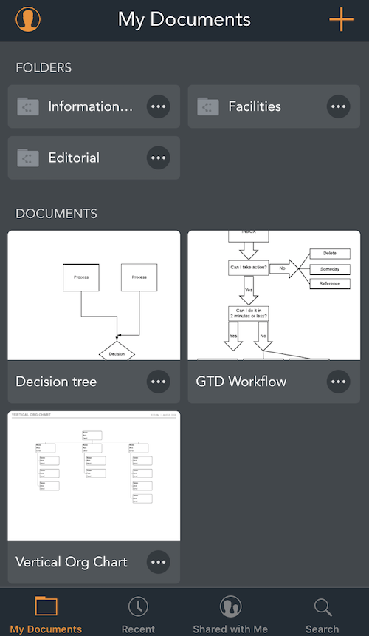

**If you've never picked up diagramming and flowchart software, you should, and you should start with Lucidchart. It has universal appeal in helping people create professional diagrams for both work or personal use (it's often used to create family trees, for example), and its iPhone app is surprisingly easy to use. The next time you need to make or edit an org chart, decision tree, room diagram, or other visual, you can whip it up on the spot using your finger and your phone. Lucidchart works collaboratively as well, so that you can provide comments, feedback, and corrections on other people's charts even when you're not in front of your computer. Lucidchart works most powerfully in its web app form, which syncs with the mobile apps (available for Android, too).**

**Price: free; paid accounts from $59.40/year**

### **[Evernote](https://evernote.com/?utm_source=zapier.com&utm_medium=referral&utm_campaign=zapier&utm_source=zapier.com&utm_medium=referral&utm_campaign=zapier)**[Evernote for iPhone](https://evernote.com/?utm_source=zapier.com&utm_medium=referral&utm_campaign=zapier&utm_source=zapier.com&utm_medium=referral&utm_campaign=zapier)

***Best for taking notes of all kinds***

**No other note-taking app has as much functionality on the iPhone as Evernote. Evernote lets you quickly capture any type of note, whether it's a voice memo, checklist, text note, or an image. You can snap photos that contain text, such as a page of a book or a whiteboard from a meeting, and Evernote will not only save them so they're accessible to you any time, but also make the text searchable using optical character recognition (OCR). It works for both typed text and handwriting. It's an excellent app for productivity enthusiasts and essential on the iPhone. Evernote also has apps for all major platforms, including the web.**

**Price: free**

Topic B – Entertainment & Media Software

### **Spotify**

****Free (subscription required); iPad, iPhone and Android

### **Sonos controller**

****Free; iPhone, iPad and Android

Turn your mobile device into a virtual control for any Sonos system. It has now been updated to sync with the latest Sonos Play:1 speaker.

### **Soundcloud**

****Free; iPhone, iPad and Android

Designed as a social network for music enthusiasts and artists, SoundCloud’s platform gives users the opportunity to explore everything from audio-books to weekly podcasts from the White House.

### **Netflix**

****Free (subscription required); iPad, iPhone and Android

Box-set junkies love Netflix for its exhaustive back catalogue of on-demand titles, as well as a growing collection of original series (including the stellar House of Cards). The pin-sharp visuals and new AirPlay function for iOS 7 users – allowing devices to sync with any Apple TV – make the £5.99 subscription worth every penny.

## 

## 

## 

## 

## 

## **7. Snapchat**

An odd little app launched in 2011 with the name Picaboo, and it quickly became known for its signature “ephemeral” messages. A few months later, Picaboo disappeared and was reborn as [Snapchat](https://itunes.apple.com/us/app/snapchat/id447188370), and its signature ghost was on the way to being a star. Guided by its young cofounder Evan Spiegel, the app quickly took off with college students and teens who helped buoy the app from obscurity to the top of the charts in the span of a year. Its design was confusing and not intuitive at all — and offered little guidance for newcomers — but all that was intentional, the app equivalent of a “no parents allowed” sign. Though its popularity with tweens is frequently attributed to their affinity for PG-13 activities, the reasons for Snapchat’s popularity are much more complex. (If not, then any one of the myriad of better-designed copycat apps would have unseated it by now.) In a world where Instagram likes can dictate social standing and cyberbullying abounds, Snapchat was able to capitalize on its younger users’ need for authenticity. While Instagram is all about making a moment look perfect, Snapchat is about sharing whatever is happening right now — awkward selfies, blurry videos, silly faces and all. It may sound like a small distinction but it’s one that’s helped the app become one of the most-loved apps among notoriously hard-to-impress teens, an area that Facebook — for all its social-media might — has struggled with. When Snapchat turned down what was reportedly a $3 billion offer from Facebook, many onlookers were, predictably, shocked. But with a new media platform in Snapchat Discover, sponsored stories, geofilters, channels, and selfie lenses, the company has shown it has business smarts, too. Even though Snapchat is now more popular, and more mainstream, than ever, grown-ups may never *really* understand it. But that’s kind of the point.

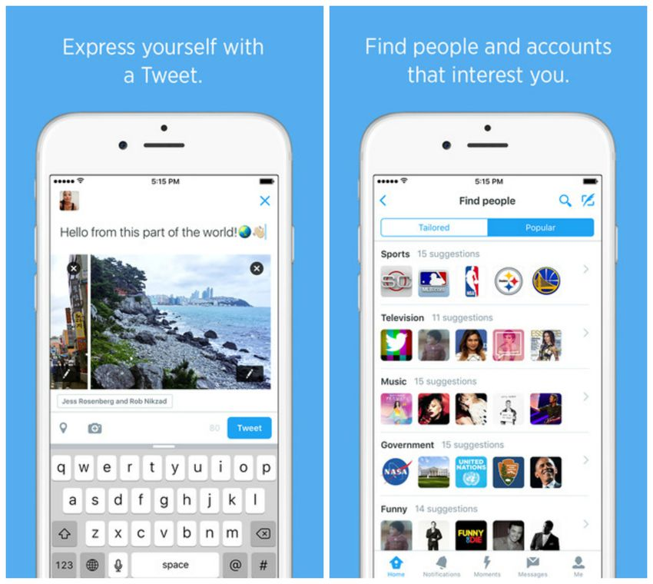

[**PREV**](https://mashable.com/2015/12/10/best-social-iphone-apps-of-all-times/#) **1415 [NEXT](https://mashable.com/2015/12/10/best-social-iphone-apps-of-all-times/#)**

## **2. TwitterIt took a little too long for** [**Twitter**](https://itunes.apple.com/us/app/twitter/id333903271) **to deliver an iPhone app. In fact, Twitter never really did. Instead, the company bought popular app Tweetie and built upon its platform (though it's likely that whatever Tweetie code existed is long since gone). Today, the native Twitter client app’s utility and importance is undeniable. Having a dedicated app that Twitter could focus on and promote helped Twitter, for a time, experience almost meteoric growth. With its tabbed interface and sharp aqua design, it’s a rich app that highlights the best Twitter has to offer, while it makes it easy to discover the service's newest features (hey, look at those Moments!). Twitter is now struggling to grow its user base, but there's no question that little aqua bird and the iPhone have helped each other fly high.**

**IMAGE: TWITTER**

Topic C – Programming Tools & Environment

DOCUMENTATION

1. As any programmer would confirm, documentation is one of the main attributes at the initial stages of iOS application development.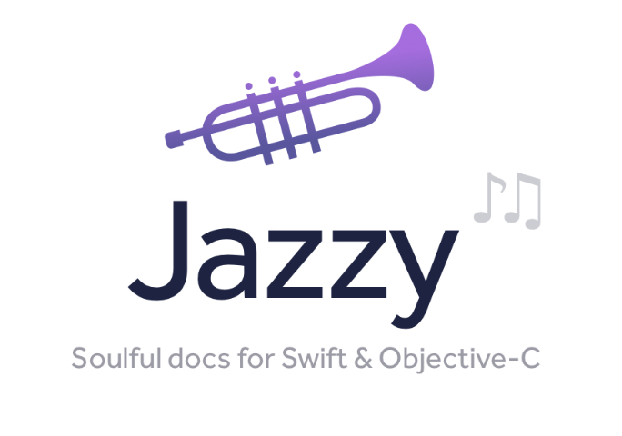

[Jazzy](https://github.com/realm/jazzy)This command-line utility can produce an Apple-style documentation for Swift and Objective-C. Jazzy uses SourceKit and the Clang AST representation of your code and its comments for generating more accurate results. In fact, this tool creates a standalone website with every part of your code and the documentation you’ve written in it. The clear and simple output it generates can be installed in the popular Dash documentation viewer.

## 

## 

## 

## DEBUGGING TOOLS

Identifying bugs is an important part of iOS mobile app development but what is even more important is finding out the real cause of each error. The following debugging tools are designed to help you with this task.



[Hyperion](https://github.com/willowtreeapps/Hyperion-iOS):Hyperion is a design debugging solution that can be integrated into any iOS app. This iOS app development tool sits discreetly under your application so that you can easily use it to inspect your program whenever you need it. Hyperion offers three default plugins: the View Inspector to check the properties of any view, the Measurements plugin to measure the distance between two views, and the Slow Animations plugin which allows reducing animation speed in-app.

BACKEND SERVICES

As it often happens, developers are aimed at providing their iOS apps with some extra functionality like the ability to share data with a server, send push notifications, and so on. The following iOS development tools will be a good choice for this purpose.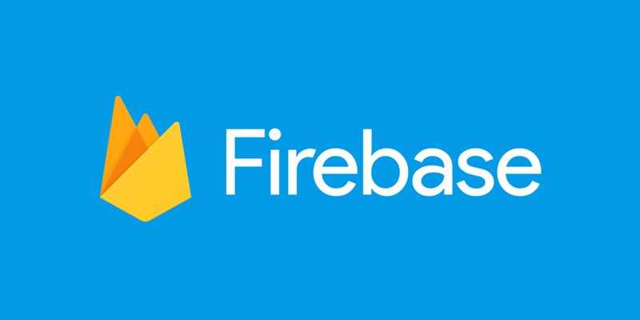

[Firebase](https://firebase.google.com/):Firebase is a BaaS  (Backend-as-a-Service) that can be your server, datastore, and API at the same time. With Firebase there’s no need to write any backend code. The solution will let you store and sync data over all your clients in real time. Any time data changes, Firebase updates apps on every device (mobile or web). In case your Firebase-powered app is working offline, its data will be synchronized once it regains connectivity.

## REVISION CONTROL

**If an iOS app is being created by a team of developers, a revision control is crucial to the project’s success.**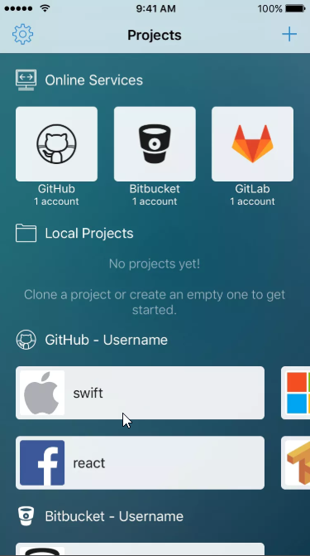

[**Source**](https://itunes.apple.com/app/source-git-client-and-code-editor/id1186180369)**:Source is a git client and code editor for iOS devices. It works as an efficient code editor that supports syntax highlighting for more than a hundred languages. Source is a git client so you can commit, pull, push, branch, etc. with specific integrations for GitHub, Bitbucket, and Gitlab.**

**The great thing about the tool is that it provides an integrated coding keyboard with common programming characters which can be used over iOS as a third party keyboard.**

Topic D – System Tools

Topic E – Software Security & Updates

Topic F – File System & User Accounts

Topic G – Special Features of your OS

Topic H – Limitations of your OS

<https://zapier.com/blog/best-productivity-apps-for-iPhone/>

<https://www.telegraph.co.uk/technology/mobile-app-reviews/10510449/The-25-best-entertainment-apps-to-download-now.html>

<https://mashable.com/2015/12/10/best-social-iphone-apps-of-all-times/#38u2PO7ygiql>

<https://www.flexihub.com/best-ios-development-tools>